EXPEDITION JATAPU RIVER 8 - 10 DAYS

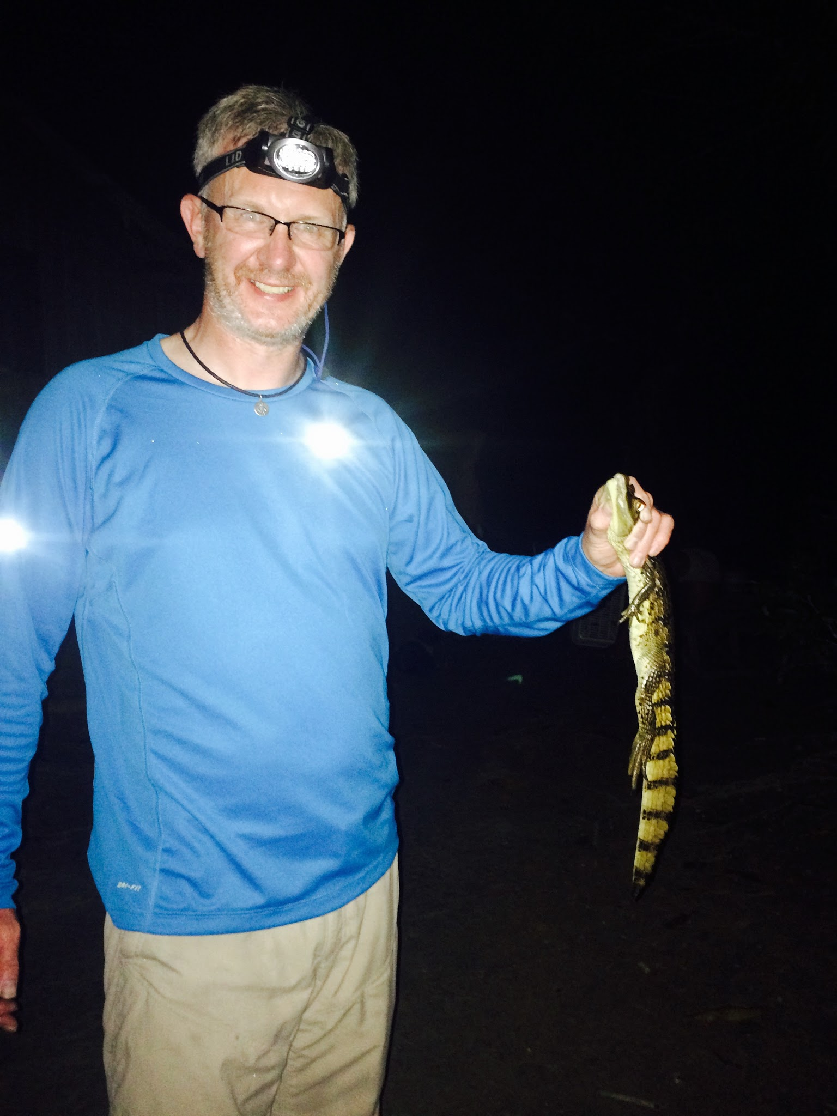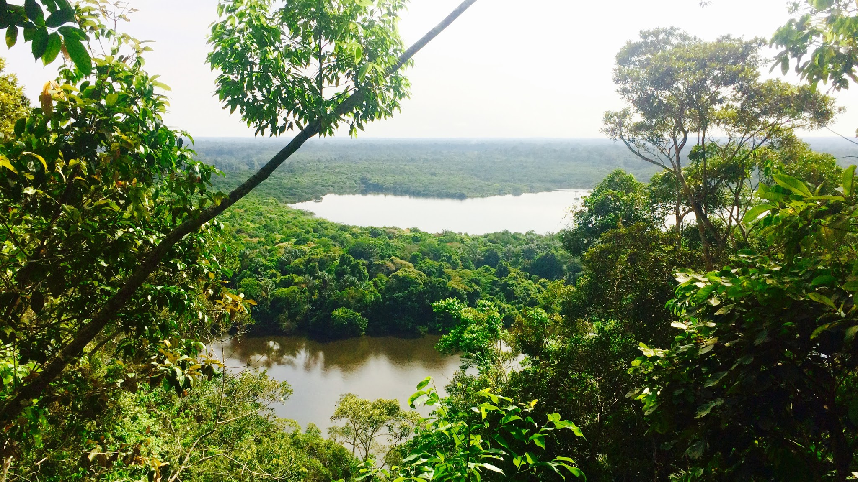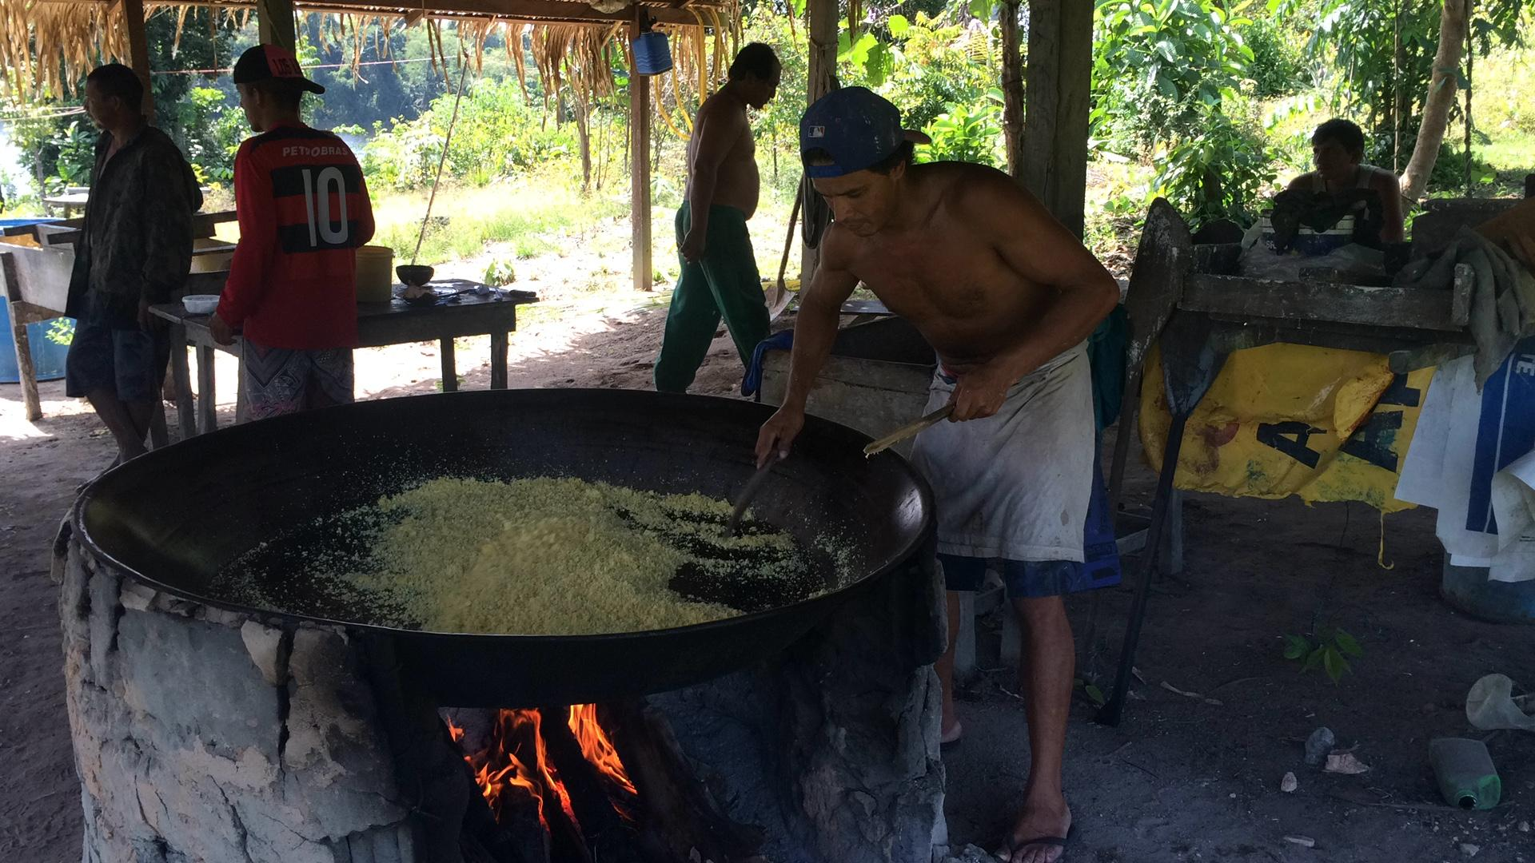

The Amazon jungle and the river Jatapu will open its beautiful scenery for you while sightseeing boat and kayaking through its lush forest.
Morning kayaking early (6:00) can be a good choice, because it increases the possibility of seeing rare animals like tapirs, electric eels and the magnificent harpy. In the evening kayak trip is always exciting to observe nocturnal animals, including alligator spotting.
At the bottom of the river Jatapu, adventurers will go through an ecosystem of different forest. In this area, the width of the river will be higher with some small lakes and entrances on the sides. There will be very quiet streams, where we can see monkeys, coatis (raccoon family) and egrets.

Itinerary

Day 1

- Pick up at the Hotel in Manaus at 8am
- Car transfer Manaus - Itapiranga (about 5 hours, 340 km), with a break in the village of Lindóia.
- Arrival in Itapiranga, boarding the regional boat
- Beginning of the Expedition
- Sleeping in a hammock on the boat or camping on the Uatumã River

Day 2

- Boat trip up the Jatapu River, General information about the river and its communities.
- Birdwatching, and dolphins are also common.
- Sleeping in a hammock on the boat

Day 3

- Kayak (about 4 hours).
- Visit to the local resident
- Possibility of fishing
- Camping in the jungle
Day 4

- Kayaking and Hiking
- Visit to flour house (traditional manioc plant processing)
- Camping in the jungle with a privileged view of the Serra do Bacabau.

Day 5

- Down the Jatapu River by kayak
- Visiting and exploring small lakes
- Visit the local family and trail in the forest to a small and refreshing waterfall.
- Sleeping on the boat or camping *

Day 6

- Kayaking
- Visit the Ararinha Community, receive local knowledge
- Night Walk
- Animal night spotting
- Sleeping on the boat or camping *

Day 7

- Dawn Kayak
- Down the Jatapu River from Barco
- Visit to the City of São Sebastião do Uatumã
- Sleeping on the boat or camping *

Day 8, 9 or 10

- Down the Uatumã River by boat
- Arrival in Itapiranga
- Return by car to Manaus (5 hours)
- Arrival Forecast (3 - 6 pm)

On 9 and 10 day expeditions, more kayaking, hiking and visits to local families are added.

All meals are included: breakfast, lunch and dinner.

*Sleeping on the boat or doing camping will depend on the client's wishes, weather conditions and river level.

DESCRIPTION OF ACTIVITIES

1. SCENIC KAYAKING

The Amazon jungle and the Jatapu River will open its beautiful surroundings to you while kayaking through its luxuriant rainforest. Through the whole expedition, you will spend time kayaking through a variety of waters.

Early morning kayaking (6:00 am) may be a good choice since leaving from this specific area, will give you the best chance to see rare animals like tapirs, electric eels and the magnificent harpy eagle. Then, night kayaking is always exciting, as you head for your Nocturnal Animal Observation*, including the alligator spotting.

In the lower part of the Jatapu river, adventurers will go through a different rainforest ecosystem. In this area, the river will be larger with a few small lakes entrances on the sides. There will very quiet streams where we may see monkeys, coatis (raccoon family) and white herons.

2. HIKES THROUGH VIRGIN, UNINHABITED JUNGLES

Some areas of the Jatapu River are in the higher land ecosystem with hundreds of plant species and trees up to 60 meters high (200 feet). In this ecosystem, the intertwined canopy in some areas can totally block the passage of light making the area extremely humid, obscure and with little ventilation, yet, amazingly beautiful.

This activity will have you trekking in the higher land rainforest. As needed, we’ll clear trails and stop frequently when we find interesting medicinal plants, resins to make torches, water-vines and much other fascinating information from our guide’s vast knowledge. He’ll also show you how to live from the rainforest with some basic survival techniques.

Have to mention here the Night Hiking! On your way to the overnight camping in the deeper rainforest” ☺

3. PIRANHA AND PEACOCK BASS FISHING

Around 15:30 (3:30 pm), it’ll be time for the piranha or peacock bass fishing excursion that will continue until dusk. Sometimes, freshwater pink and/or gray dolphins come close during this fishing activity, attracted by the same noise (splashes on the water) made to attract the piranhas. This is a perfect time to see couples of green parrots flying back home to sleep. Back at the camp, the guides will prepare 2 options for dinner: a classical meal or, if the fishing was successful, a piranha fish soup – a famous aphrodisiac.

4. NOCTURNAL ANIMAL OBSERVATION

This activity will be done after sunset using spotlights to localize the animals by the reflection of their eyes. The guide will try to catch a caiman/alligator without hurting himself or the animal using his experience and techniques. For the brave ones, it’s possible to hold the caiman, assuming it’s not over a meter (3 foot) long. After some explanations and a few pictures, the guide will slowly set the caiman free. Other nocturnal animals, like spiders, snakes, owls or giant frogs could also be seen.

5. OVERNIGHT CAMP DEEP IN THE JUNGLE

Late in the afternoon, the rainforest tracker will guide trekkers as far as they wish for the overnight camping in the deeper rainforest. Basic camping gear, smaller hammocks and prepared food will be put in everyone’s daypacks and carried into the mysterious rainforest. This is a once in a lifetime experience, to be in the middle of the deep Amazonian rainforest, in total darkness, listening to and trying to view nocturnal animals. Most animals are not seen during the day, as 80% are nocturnal. Sometimes, animals may come very close to the camping place since we don’t make any fire as to better welcome our night visitors. This is a safe and mysteriously thrilling experience ☺

6. SUNRISE AND SUNSET OBSERVATION

Sunrise and sunset in the Amazon are around 6:00am and 6:00pm. A spectacular mix of yellow, orange and reddish colors in the sky blending in the waters and the different shade of greens from the forest, it’s enchanting. When still, the reflection effect is so perfect that you have to look twice to see where the water, forest or skyline is. It’s one of the most beautiful and photographic landscape the Amazon has to offer. The sound of the birds waking up or going to sleep also complements this unique atmosphere.

7. MEET LOCAL DWELLERS FAMILIES AND/OR SMALL VILLAGES

Locals are very friendly and receptive; you can experience firsthand, part of their reality and the way of life of the people of the Amazon. You can learn about the traditional manioc plant processing, a staple crop, and discover how they extract the poisonous liquid from the roots. If you are lucky, you may see local people carving a canoe or a homemade 15 meters (50 feet) motorized wood fishing boat. In exchange for the visit, sometimes clients like to give gifts of school supplies like colorful crayons, perfumes, soccer ball.

8. OVERNIGHT IN A FAMILY’S HOME (BY REQUEST)

If you’d like to extend this cultural encounter, an overnight can be arranged, normally done in the last night of the trip when everyone is a bit tired and want to take it easy with the activities or camp mounting.

What’s Included
- Pick up at the airport
- Pick up and drop off at the hotel
- English speaking guide
- Food and water
- ‘Caipirinha’ drink
- Canoeing and camping equipment
- Support boat
- Tourism insurance

What’s Not Included
- Breakfast on the first day
- Personal hygiene products
- Towel

